**SPH3U: 1.4 Comparing Graphs of Linear Motion**

1. **Acceleration-time graphs**

|  |  |
| --- | --- |
| Acceleration-time graph: |  |

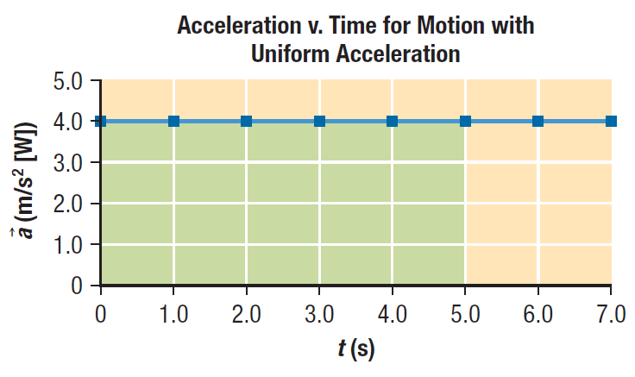

Area =

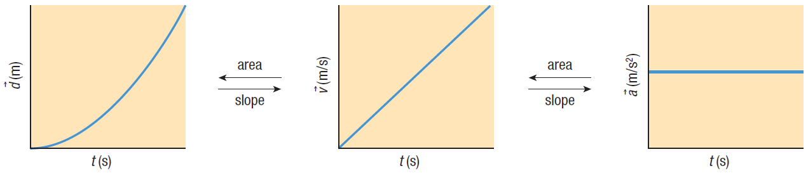

Use the acceleration-time graph above to generate velocity and time data for the object. Then use these data to plot a velocity-time graph.

|  |  |  |  |
| --- | --- | --- | --- |
| **Time** *t* (s) | **Acceleration**  (m/s2 [W]) | **Equation $$∆\overset{⃑}{v}=\overset{⃑}{a}∆t$$** | **Velocity $\overset{⃑}{v}$**  (m/s [W]) |
| 0 |  |  |  |
| 1.0 |  |  |  |
| 2.0 |  |  |  |
| 3.0 |  |  |  |
| 4.0 |  |  |  |
| 5.0 |  |  |  |

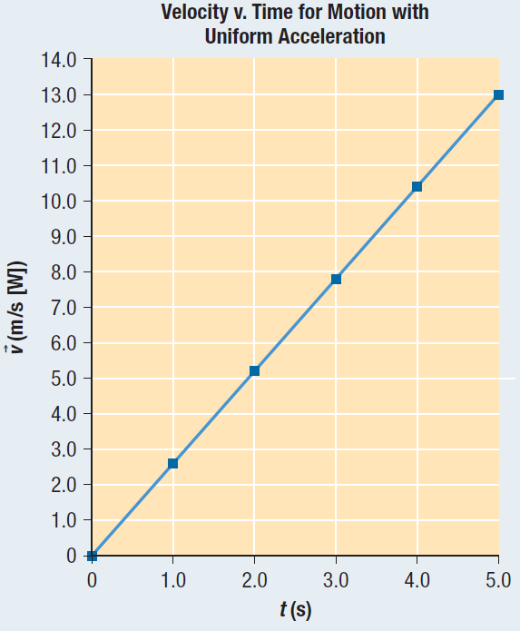Use the velocity-time graph shown to the right to plot the corresponding acceleration-time graph.

1. **Summary**

**Homework:** page 35: #1-4